Using past player match performance, predict their skill level or win probability in the next match
- Predicting CS2 Match Outcomes from Team Statistics
- Win Probability Prediction in Counter-Strike 2 Using Machine Learning
- Classifying CS2 Match Results with Logistic and Ensemble Models
Introduction
Competitive matchmaking systems aim to place teams of similar skill so that games are fair and engaging. In this project, we tackle the problem: given past team performance statistics, predict the next match outcome. Accurate pre-match prediction is valuable for analytics, scouting, and evaluating balance without needing live telemetry.
We use a Counter-Strike 2 dataset containing map identity, team identifiers, and aggregate team features such as average win percentage, K/R (kills per round), and Elo-like ratings. After cleaning the raw files (12,123 rows, 50 columns) and removing non-informative artifacts, we obtained a modeling table with 3,601 matches and 9 usable features. The target is a 3-class outcome: team a, team b, or win (a dataset-specific label indicating clear winner cases).
We build several models—baseline Logistic Regression, Random Forest, Gradient Boosting, a balanced Polynomial Logistic Regression, and a soft-voting ensemble. The best model on a held-out test set achieved 88.9% accuracy with a macro ROC–AUC of 0.967, showing that simple pre-match statistics already carry strong predictive signal.
Contributions
- Reproducible preprocessing pipeline for CS2 match data (merge, clean, encode, impute, split).
- Systematic comparison of linear, tree-based, boosted, and ensemble classifiers.
- Balanced training and polynomial feature interactions that improved minority-class performance (team a / team b).
- Clear evaluation artifacts: comparison table, confusion matrix, and ROC curves for the best model.
Report structure. The rest of the report covers related work, the dataset and preprocessing, modeling approach, results, limitations, and conclusions.

Literature Review
Predicting skill levels and outcomes in esports has been explored in multiple recent works. We highlight three relevant studies.
- Identifying player skill of Dota 2 using ML (2024).
This study predicted player skill levels from single-match statistics in Dota 2 using Logistic Regression, Random Forest, and XGBoost. The dataset was collected via the OpenDota API. Evaluation showed precision ~0.71, F1 ~0.64, ROC AUC ~0.81. While results confirmed machine learning models capture skill patterns, the work was limited to single-game samples and did not include team dynamics.
- Real-time eSports Match Result Prediction (2016).
This work predicted outcomes in Dota 2 across match progression. Using Logistic Regression and an Attribute Sequence Model, the authors trained on ~78,000 matches with replay-derived features. Accuracy was ~59% pre-match, rising to ~93.7% by minute 40. This demonstrated strong predictive potential but required live data streams, limiting applicability for static pre-match prediction.
- Machine Learning Applications in MOBA Esports – A Systematic Review (2025).
This systematic review surveyed 35 studies on prediction tasks in Dota 2 and League of Legends. It reported common use of Random Forests, Neural Networks, and Logistic Regression for outcome prediction. Findings showed that even simple statistical features yield strong predictive models. However, it emphasized challenges such as heterogeneous datasets and the lack of semantic or teamwork-based features.
Summary. Across these works, ML methods consistently outperform simple heuristics. Linear models provide interpretable baselines, tree-based models capture nonlinearities, and boosting often improves accuracy further. Key gaps remain in modeling team coordination and dynamic updates to skill ratings. Our study builds on this literature by applying multiple algorithms—including ensembles—on CS2 match-level statistics, and explicitly handling class imbalance and feature interactions.

Dataset and Preprocessing
Dataset.
We used a Counter-Strike 2 (CS2) dataset sourced from Kaggle. The raw archive contained 12,123 rows and 50 columns spread across multiple Excel sheets. Initial inspection revealed many non-informative or corrupted headers (e.g., floating-point column names and UUID-like strings). After cleaning and filtering, we reduced the dataset to 3,601 matches with 9 usable features.
Features.
The final input variables included:
- map: categorical indicator of the map (e.g., Mirage, Nuke, Inferno).
- team a, team b: categorical identifiers for the two sides.
- Team_A_avg_win_percentage, Team_B_avg_win_percentage: numeric, pre-match win rates.
- Team_A_avg_KR, Team_B_avg_KR: numeric, average kills per round (K/R).
- Team_A_avg_elo, Team_B_avg_elo: numeric, Elo-like skill ratings.
Target.
The target column was the match outcome with three classes:
- team a (class 0)
- team b (class 1)
- win (class 2, dataset’s label for clear winners)
This created a 3-class classification problem. The class distribution was slightly imbalanced, with ~40% win cases and ~30% each for the other two.
Preprocessing.
Steps included:
- Column cleaning → removed invalid headers and non-informative identifiers.
- Encoding categoricals → maps and team names encoded using LabelEncoder or OneHotEncoder.
- Imputation → missing numeric values filled with column means; categorical missing values filled with mode.
- Scaling → StandardScaler applied to numeric features for linear models.
- Train-test split → 80/20 split stratified by target labels to maintain balance.
After preprocessing, the dataset was ready for modeling with a consistent numeric feature matrix (X_train, X_test) and encoded target (y_train, y_test).
Final Cleaned Dataset
After preprocessing, we obtained the following feature set and class distribution:
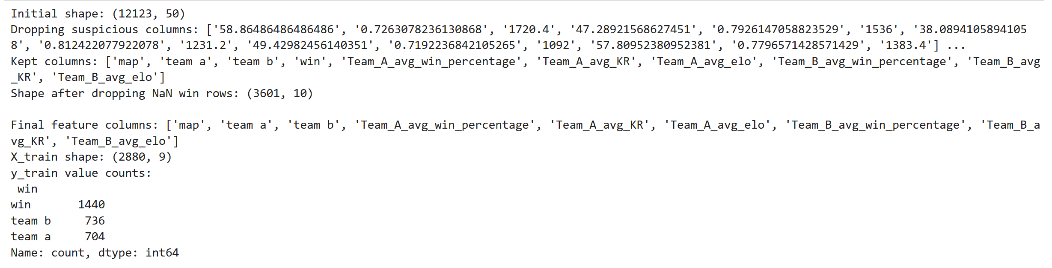
Figure 1. Final dataset features, training split shape, and target distribution
Methodology
To evaluate predictive performance, we systematically applied a range of machine learning models, progressing from simple baselines to more advanced ensemble methods. The pipeline was designed to be reproducible and fair, using the same train/test split and consistent preprocessing across all models.
Baseline Model.
- Logistic Regression (multinomial): Served as the first baseline to capture linear separability of the outcome classes. Polynomial feature expansion was later added to capture interactions between win rate, K/R, and Elo.
- Class imbalance was mitigated using class_weight='balanced'.
Tree-Based Models.
- Random Forest Classifier: An ensemble of decision trees, well-suited for handling nonlinear relationships. We tuned hyperparameters such as the number of trees (n_estimators), maximum depth, and minimum samples per split using GridSearchCV.
- HistGradientBoosting Classifier: A boosting-based algorithm optimized for tabular data. It handles missing values natively and incrementally improves weak learners into a strong model.
Polynomial Logistic Regression.
- A pipeline combining imputation, scaling, polynomial feature expansion, and Logistic Regression with class balancing.
- This model improved the discrimination between team a and team b, which were harder to classify compared to the dominant win class.
Ensemble Approach.
- Voting Classifier (soft voting): Combined predictions from Polynomial Logistic Regression, Random Forest, and HistGradientBoosting.
- Soft voting aggregated class probabilities, yielding a more stable predictor.
Evaluation Strategy.
- All models were trained on 80% of the data and tested on the remaining 20% hold-out set.
- Performance was measured using Accuracy, Precision, Recall, F1-score, and ROC–AUC (macro-averaged for the 3 classes).
- Visual evaluation included confusion matrices, ROC curves, and an accuracy comparison bar chart.

Figure 2. Modeling pipeline and ensemble definition:
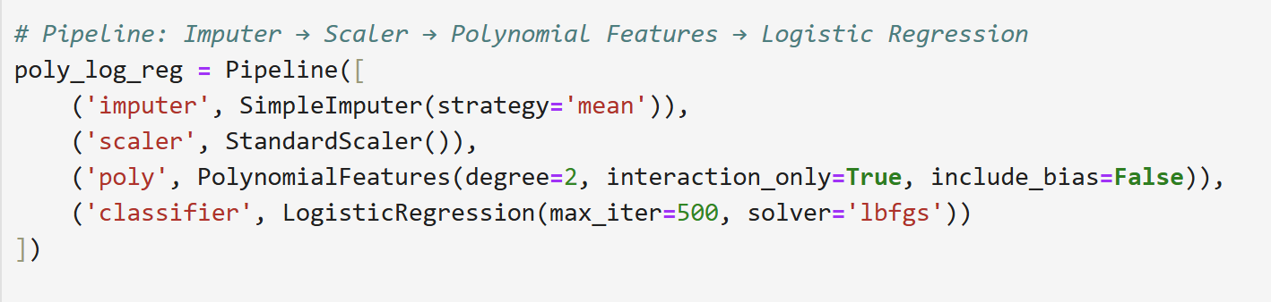

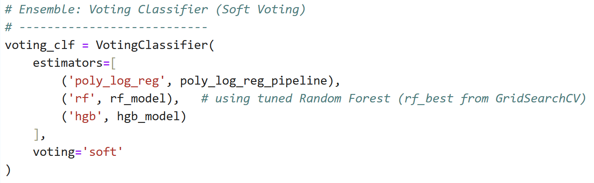

Results
We evaluated all models on the 20% hold-out test set. Performance was measured using accuracy, precision, recall, F1-score, and ROC–AUC.
Model Comparison.
Table 1 summarizes the accuracies of the main models:
Model | Accuracy
Balanced Polynomial Logistic Regression: | 0.889
Random Forest Classifier: | 0.874
HistGradientBoosting Classifier: | 0.868
Voting Ensemble: | 0.874
The Balanced Polynomial Logistic Regression achieved the highest accuracy (88.9%) and also the highest macro-averaged ROC–AUC (0.967), making it the best model overall.
Class-level Performance.
- The win class was consistently predicted with near-perfect precision and recall.
- The more difficult team a and team b classes improved under polynomial features and class balancing (F1 ≈ 0.76–0.78 compared to ≈0.74 in simpler models).
- This shows that adding interactions between features (win%, Elo, K/R) helps distinguish between closely matched teams.

Visual Evaluation.

- Figure 3: Bar chart comparing model accuracies.
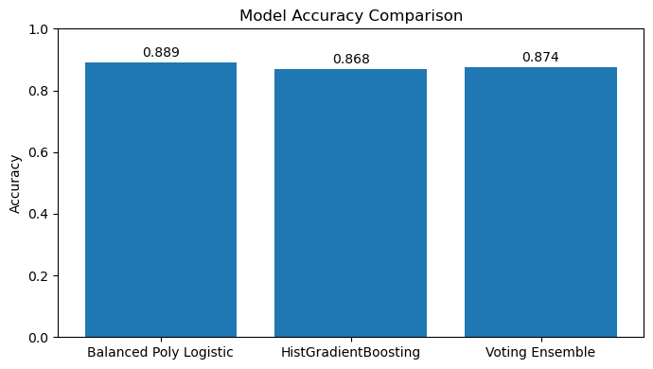

- Figure 4: Confusion matrix for the best model (Balanced Polynomial Logistic Regression):
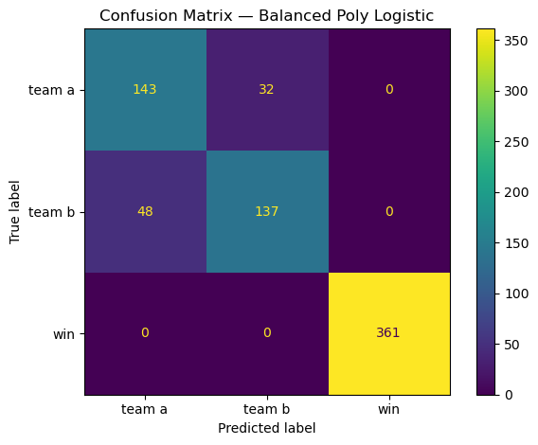

- Figure 5: ROC curves with macro-average AUC = 0.967.
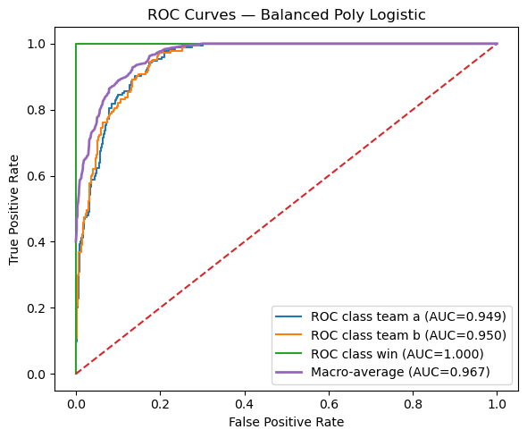

Together, these results demonstrate that even simple pre-match statistics can produce accurate outcome predictions when combined with appropriate modeling techniques.

Limitations
Although the models achieved strong predictive performance, several limitations remain:
- Dataset scope.
The dataset included only aggregate team-level statistics (average Elo, K/R, win percentage). It did not capture deeper player-level dynamics such as role specialization, individual map performance, or in-game tactical choices.
- Class imbalance.
The outcome label was not perfectly balanced. The win class was over-represented compared to team a and team b. While class weighting improved balance, the minority classes still had slightly lower F1-scores.
- Static prediction.
The models predicted outcomes before matches based only on historical averages. In practice, performance depends on many dynamic factors such as player form, opponent strategies, and team communication, which were not available in this dataset.
- Generalizability.
Elo and other performance indicators are constantly updated in real matchmaking systems. A static model trained on a fixed dataset may not adapt well to future matches without retraining.

Conclusion and Future Work
This study demonstrated that machine learning can effectively predict Counter-Strike 2 match outcomes based on pre-match team statistics. Starting from baseline Logistic Regression and progressing through Random Forest, Gradient Boosting, and ensemble methods, we found that a Balanced Polynomial Logistic Regression model achieved the best performance with 88.9% accuracy and a macro-average ROC–AUC of 0.967.
The results confirm findings from prior literature: even relatively simple statistical features (Elo, K/R, win%) provide strong predictive signals. At the same time, our experiments highlighted that handling class imbalance and modeling feature interactions are critical for distinguishing closely matched teams.
Future work can improve on these results in several ways:
- Incorporating player-level and role-specific features (e.g., entry fraggers, support players) for finer-grained predictions.
- Using time-series and in-game telemetry data to enable real-time prediction as matches progress.
- Exploring deep learning architectures (e.g., recurrent or graph neural networks) to capture nonlinear dependencies and team dynamics.
- Integrating models with live Elo/MMR update mechanisms to better reflect evolving player performance.
Overall, this project shows that with careful preprocessing, feature engineering, and model selection, machine learning offers valuable tools for analyzing and predicting competitive esports outcomes.

